Bug Report 1

Title: DELETE request successfully deletes non-existing post ID 999

Method: DELETE

Endpoint: /posts/999

Severity: Medium

Request:

{}

Expected Result:
The API should return an appropriate error response because post ID 999 does not exist. The available posts are limited to IDs 1–100.

Actual Result:
The API successfully processes the DELETE request for post ID 999, even though the post does not exist.

- Steps to Reproduce:
Send a DELETE request to /posts/999.
- Post ID 999 does not exist because the available posts are limited to IDs 1–100.
- Send the request.
- Observe the response.
- Verify the response status code.
- Notice that the API returns 200 OK and processes the deletion successfully instead of returning an appropriate error.
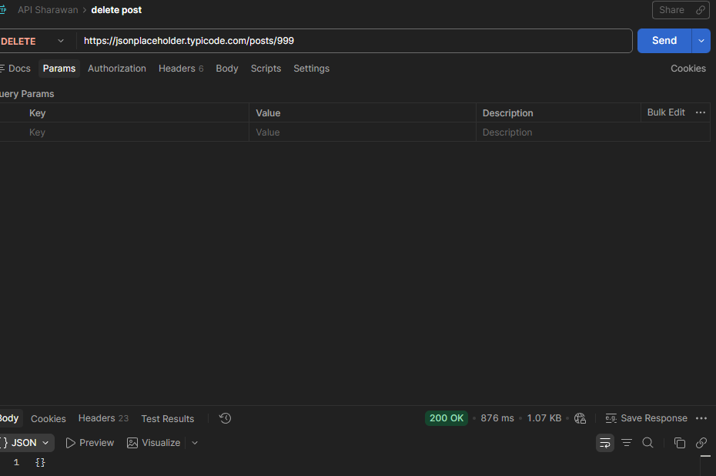
Additional Notes:

Bug Report 2

Title: POST API accepts an empty request body and generates a new post ID

Method: POST

Endpoint: /posts

Severity: Medium

Request:

{}

Expected Result:
The API should reject the request because the required post fields such as title, body, and userId are missing. It should return an appropriate validation error response.

Actual Result:
The API accepts the empty request body and successfully creates a response with a newly generated post ID, despite no post data being provided.
Response / Error:
{
"id": 101
}
Steps to Reproduce:
- Send a POST request to /posts.
- Provide an empty request body {}.
- Send the request.
- Observe the response.
- Verify that the API returns a newly generated post ID.
- Notice that the API accepts the request without validating the required fields.

Additional Notes:
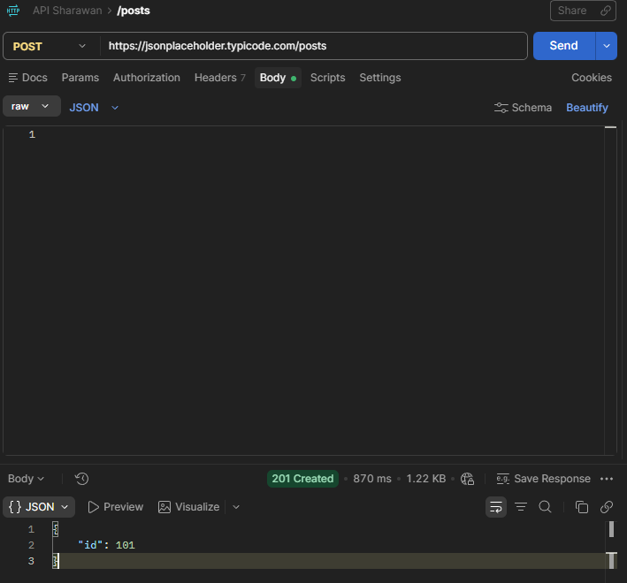
Bug Report 3

Title: POST API accepts payload with an unexpected key-value pair.

Method: POST

Endpoint: /posts

Severity: Medium

Request:

{
"userId": 1,
"id": 1,
"title": "hello title",
"body": "hello",
"email":"riyaz@gmail.com"
}

Expected Result:
The API should validate the request payload and reject the unexpected new field with an appropriate validation error response.

Actual Result:
The API accepts the payload containing the unexpected key-value pair and successfully processes the POST request instead of identifying it as an invalid payload.
Response / Error:
{
"userId": 1,
"id": 1,
"title": "hello title",
"body": "hello",
"email":"riyaz@gmail.com"
}

Steps to Reproduce:
- Send a POST request to /posts.
- Add valid post fields such as title, body, and userId.
- Add an unexpected key-value pair such as "invalidKey": "invalidValue".
- Send the request.
- Observe the response.
- Notice that the API accepts the unexpected field and creates the post successfully.
Additional Notes :
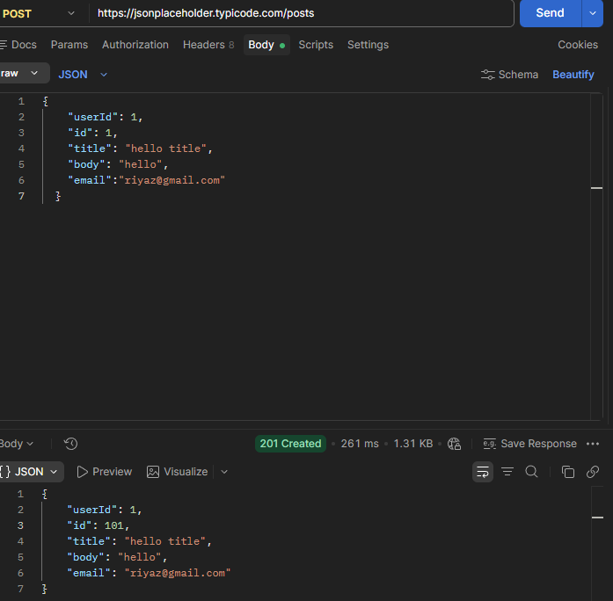
Bug Report 4
Title: POST API accepts null values and invalid data types in the request payload
Method: POST
Endpoint: /posts
Severity: Medium
Request:
{
"userId": null,
"id": null,
"title": "",
"body": ""

}

Expected Result:
The API should validate the request payload and reject null values and invalid data types. It should return an appropriate validation error response, such as 400 Bad Request.
Actual Result:
The API accepts the null value and invalid data types and successfully processes the POST request instead of rejecting the invalid payload.
Response / Error:
{
"userId": null,
"id": null,
"title": "",
"body": ""
}
Steps to Reproduce:
- Send a POST request to /posts.
- Provide null for the title field.
- Provide an invalid data type, such as a number for body.
- Provide a string value for userId instead of the expected numeric value.
- Send the request.
- Observe the response.
- Notice that the API accepts the invalid payload and generates a new post ID.

Additional Notes :



